**PROJECT REPORT TEMPLEATE RECRUITING ASSISTANT FOR HR MANAGERS TEAM ID : NM2023TMID1844720401**

## Overview :

1. **INRODUCTION**

In this project ,we use custom objects ,relationships, pages layouts to give the HR access to data they need on an existing recruitment app.

To make the existing app more efficient for the HR team we create custom objects and relationships to store and access the data more efficiently. we install an unmanaged package in the org to get metadata that acts as existing data in the recruitment app.

## Purpose :

* + - Job positing
    - Rewards & Incentives
    - Resolving conflicts
    - Performance Appraisal
    - Training & Development
    - Maintaining Healthy Work culture
    - Organizing various activities
    - Payroll Management .

## 2.Problem Definition & Design Thinking

## Empathy map :

An empathy map is a collaborative visualization used to articulate what we know about a particular type of user. It externalizes knowledge about users in order to

1. create a shared understanding of use

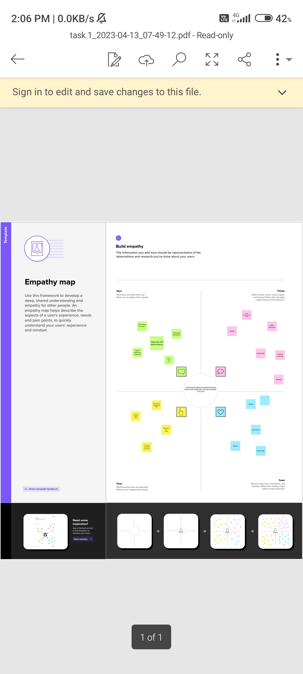

## Brainstorming :

Brainstorming is a group problem-solving method that involves the spontaneous contribution of creative ideas and solutions. This technique requires intensive, freewheeling discussion in which every member of the group is encouraged to think aloud and suggest as many ideas as possible based on their diverse knowledge.

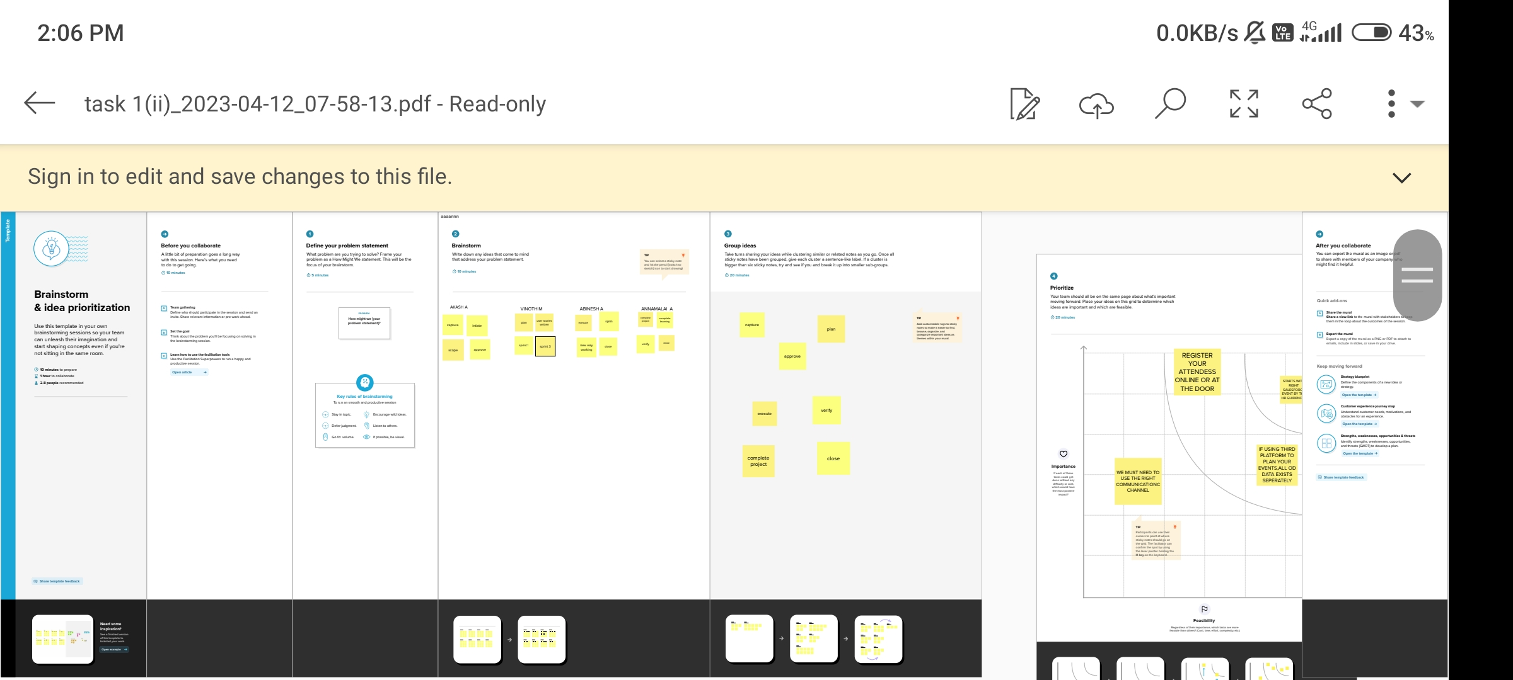

# 3.RESULT

* 1. **Data Model :**

|  |  |  |  |
| --- | --- | --- | --- |
| Object name | | Field label | Data type |
| **1** | Job positing site | Job positing site | Text |
| Job positing  URL | Job positing URL | Text |
| **2** | Review | Review | Auto- Number |
| Account | Account | Auto- Number |

# Activity & Screenshort :

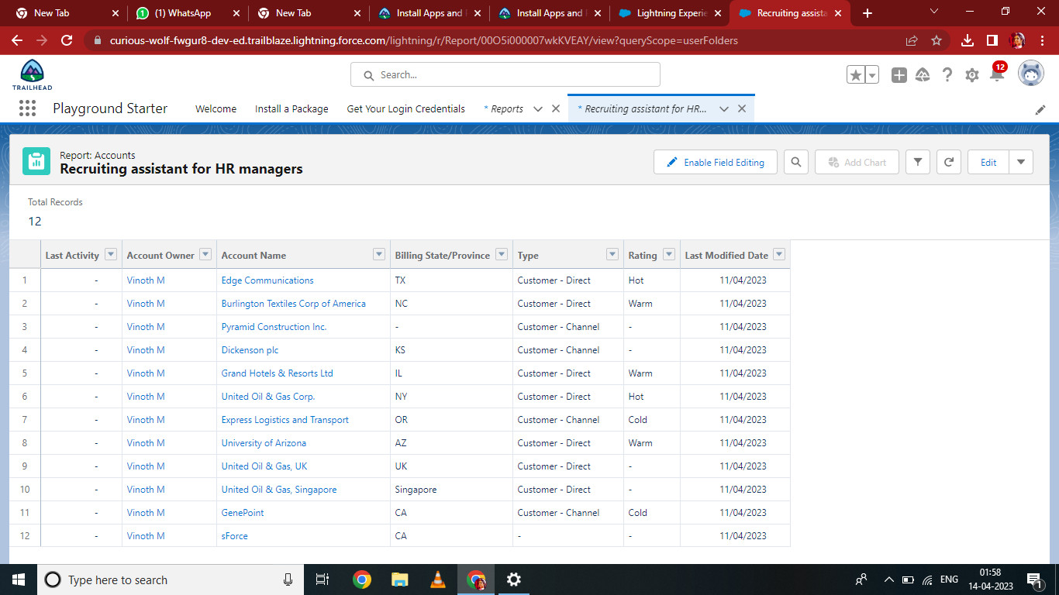

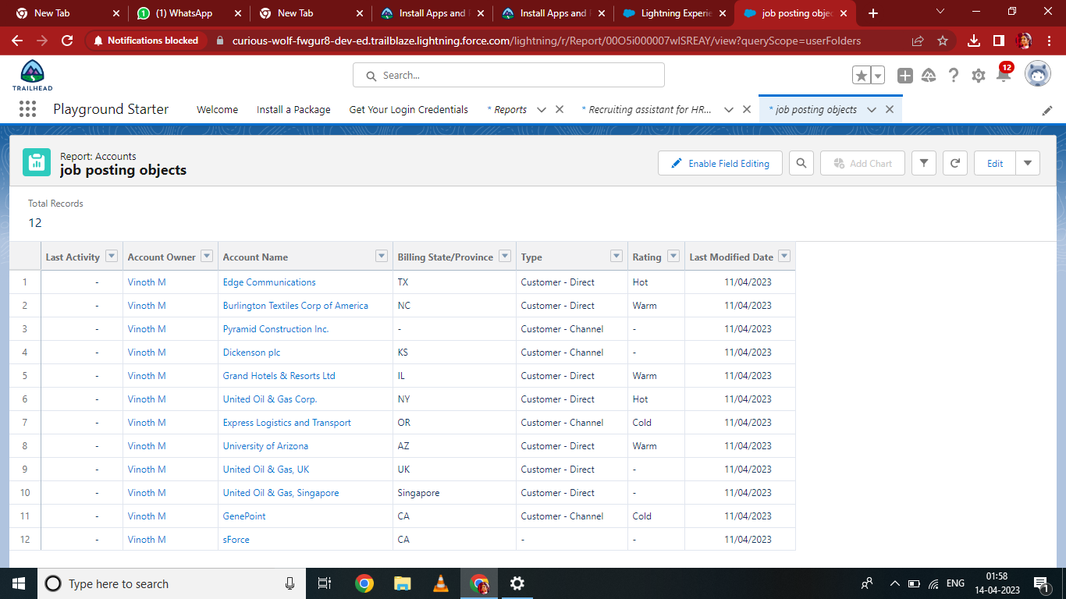

**4.TRAILHEAD PROFILE PUBLIC URL**

Team Leader – <https://trailblazer.me/id/akasa91>

Team Member 1 - <https://trailblazer.me/id/vinoth1902>

Team Member 2 -<https://trailblazer.me/id/annamalai2003>

Team Member 3 - <https://trailblazer.me/id/aabinesh4>

# 5.ADVANTAGES & DISADVANTAGES

**Advantages :**

# Disadvantages :

* Human resource planning
* Hiring workforce
* Enhance organization effectiveness
* Handles disputes and queries
* Motivating emplyees
* Improve employee relation .
* Costly setup
* Recent origin
* Unpredictability
* Improper development programmes
* Insufficient information .

# 6.APPLICATIONS

* + HRIS is a type of business application that enables companies to store employee information ,manage common HR functions ,and execute critical HR activities such as processing payroll and administering benefits.
  + Features oh HRIS application include an employee self-service portal , payroll , workforce management ,recruitment and hiring

,benefits administration ,and talent management .

* + As mentioned, HRIS applications are valuable for supporting

critical HR operations and initiatives. Let’s look at how you an apply HRIS capabilities in your business to deliver value and build a strong foundation.

# 7.CONCLUSION

In conclusion ,due many challenges that are facing human resource departments , there is need for organisations to adopt correct and workable policies that will not only ensure they alleviate these challenges but also develop mechanisms of Dellinger with such challenge in case they occur in the future .

# 8.FUTURE SCOPE

The project has a very vast scope in future . The project can be implemented on internet in future.